**Sections of the webapp**

The initial webapp will have two sections. They are:

* Cyclical Strength Index
* Quadrant Analysis

Each “Section” of the webapp is based on its own chart (which is the centerpiece of the section). The goal will be to build these charts using Plotly since they can then easily integrate with Dash!

**Chart #1 - Cyclical Strength Index**

This chart will look to mimic the one I currently have on <http://williamgorfein.com>

I would like to make some design adjustments to it… but you can get the overall point by the example currently on my website.

*Important considerations*

The main thing being graphed on this chart is “CSI” (Cyclical Strength Index). It is actually two lines. The primary line will be solid while the secondary line will need to be dotted. And just like the current example, the two lines should be similar but not the same color. For example, the primary line can be blue and the secondary line can be purple (just as they are now).

Features…

1 – Scrolling time adjuster

I would like the chart to have the scrolling range feature… such as the example here: <https://plotly.com/python/candlestick-charts/>

(and screenshot below)

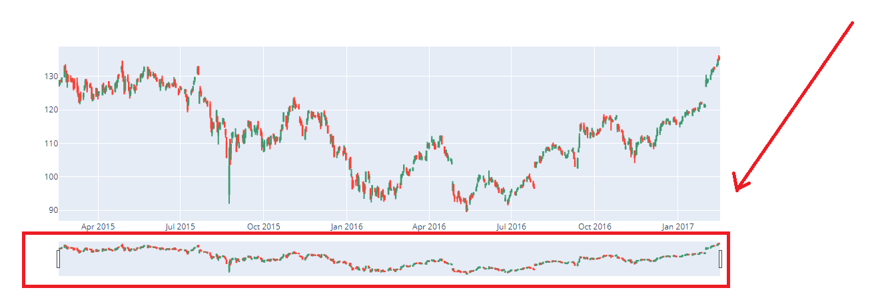

2 – Selecting additional lines to plot using a dropdown

The current version of the chart used provides the user with the following options:

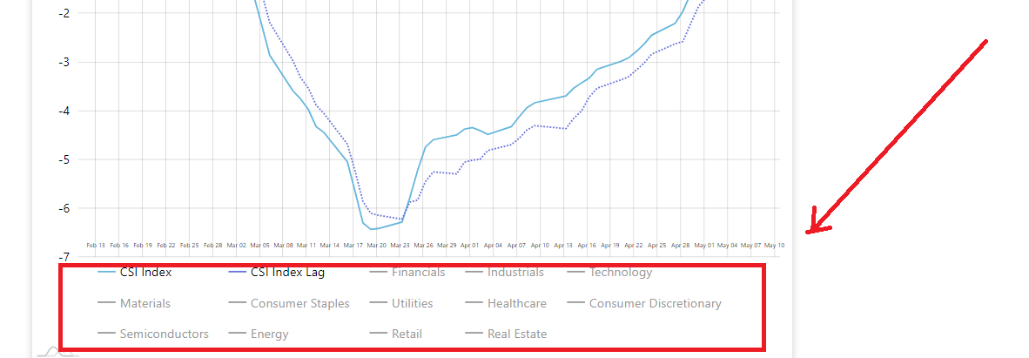

I would like to replicate this functionality using a feature that Plotly provides in a different example of theirs. Please see the following link: <https://dash-gallery.plotly.host/dash-web-trader/>

The graphs on this chart provide a feature where a hamburger dropdown can be clicked and “studies” can be added to the chart. Please see screenshot below:

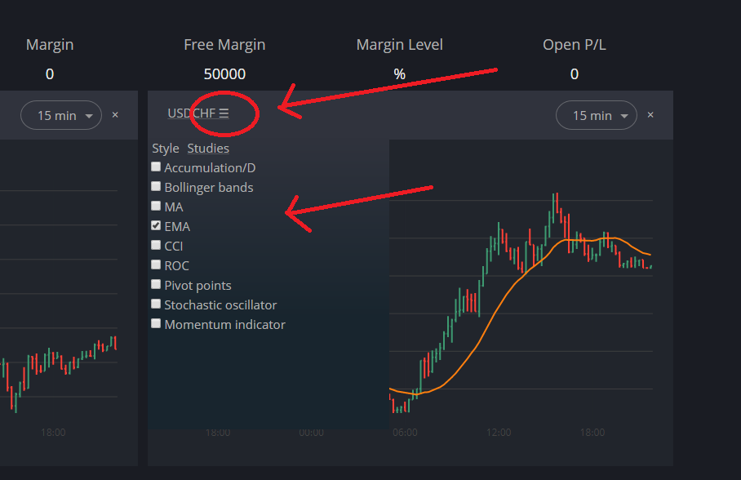

This feature will provide the user with a concise method for adding additional overlays to the graph. I would like to replicate the same feature here. Except, instead of providing technical indicators, the user will be able to select from any of the other industries that can also be graphed (Industrials, Financials, Technology, Real Estate, etc.). Just to clarify, I’m only interested in the dropdown menu providing the other industries being graphed… I do not envision the “studies” being available to the user (so this option can be removed along with the Style option).

**Chart #2 - Quadrant Analysis**

The second chart is a bit more nuanced and complex. I have tried my best to demonstrate the chart via the Jupyter notebook sent over. There will be additional features that I would like included with this chart that I’m hoping the expanded functionality of Plotly can successfully provide for us.

Primary purpose of this graph: Plot the X and Y axis datapoints for each of the stock tickers provided. I have shown an example of this in the screenshot below:

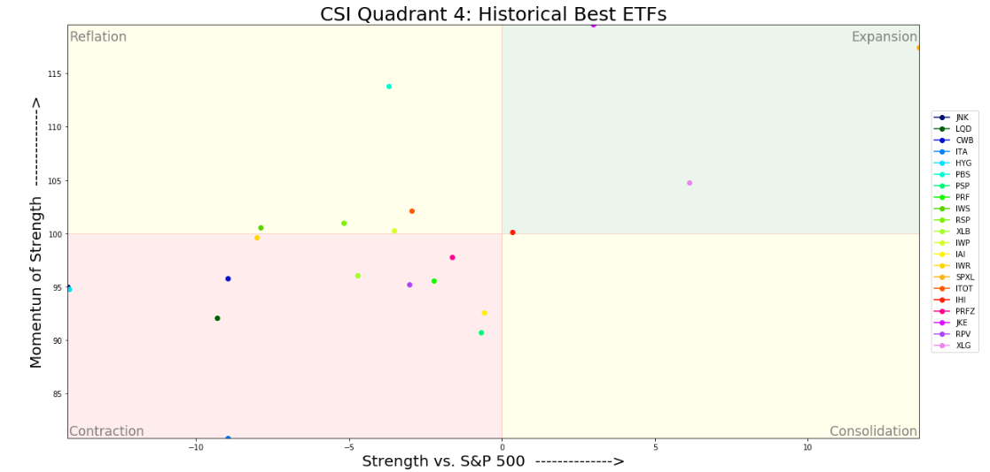

You can see in this example that each ticker has a simple X and Y coordinate that gets graphed just like in any traditional scatter plot. Simple enough. However, I would like to add other functionality to it. The main functionality I would like added is a hover feature. Where when the user hovers their mouse over a data point, a floating box appears that shows a summary of the datapoint. The summary will include the values of the X and Y coordinates, along with the name of the ticker.

The data input I’ve used in the Jupyter example is a dictionary where the ticker symbols are keys and the titles are the values. For example, {“ITA” : “Aerospace & Defense”}. When the user hovers over the datapoint corresponding to this entry, the hover would say:

Ticker: ITA

Name: Aerospace & Defense

x-value: 2.3

y-value: 94.1

Right now, its tough to tell by looking at the legend which stock ticker coincides with what specific datapoint. I think the hover functionality will fix this issue in a clean way.

Additional primary feature: Adding tickers to graph

There is also the question on how the user will be able to choose which tickers can be added to the actual graph for plotting (they all won’t be graphed by default).

I would like to borrow the functionality in the following screenshot:

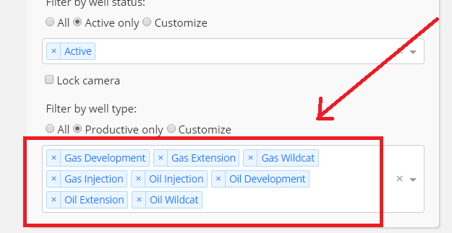

This screenshot was taken from here: <https://dash-gallery.plotly.host/dash-oil-and-gas/>

I think it provides the user with a clean way for adding tickers and customizing which are graphed. This box can be positioned above the chart.

Secondary purpose of the quadrant chart: To show historical trends for each stock ticker

I’ve included an example of this in the screenshot below. Additionally, the amount of history plotted can be toggled in the example Jupyter notebook by adjusting the “lookback” variable.

The screenshot below shows the same graph… however, the lookback variable has been set to 20.

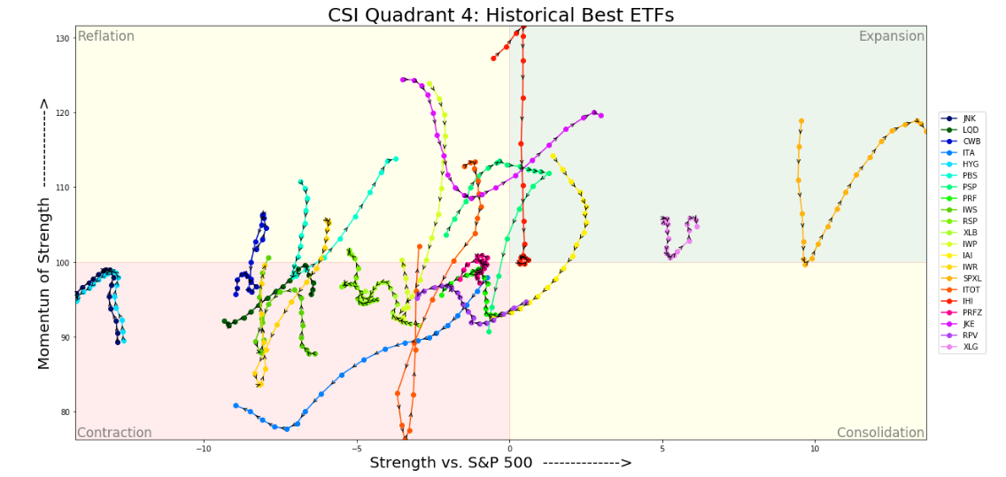

The purpose of the lookback is so that a user can see the general trend for each stock ticker graphed. I used matplotlib’s annotate function to add small directional arrows in black on each line. I would like these included in the new Plotly version too if possible. Also, I would like for the hover functionality to be available here as well so the user can easily see which line and datapoint are associated with each stock ticker.

There is one additional piece of functionality I would like added to this chart… I’d like the user to be able to dynamically set the lookback window. The user will be able to select any value between 1 – 20 (so 1 through 20 days). I have found a good example of this feature in an existing Plotly Dash example. Please see the screenshot below:

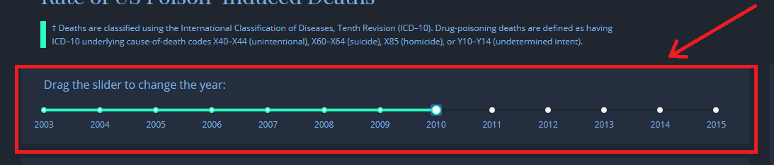

This screenshot was taken from the following dashboard: <https://dash-gallery.plotly.host/dash-opioid-epidemic/>

If its possible to adapt, I think it will make for a very nice user experience. This slider will preferably be directly underneath the graph.